**Introduction**

Now, more than ever, we need to think about the business holistically, and how technology is used makes a huge difference in how the organization grows. Therefore, the technology and business areas must be in sync.

To modernize legacy systems, the conversion plan must contain the following essential elements.

1. **Assess the current state of the systems**

Analyse all the functionality, architecture, capacity, complexity, and risks of the systems the company is working with. Set aside any systems that can't keep pace with digital demands or business growth for modernization. If something no longer offers value to the company or if the costs don't compensate for the results, even with the implementation of new technologies, maybe it's time to make a total replacement for more modern solutions.

1. **Evaluate modernization options**

Review the technologies you can count on. Remember to prioritize those that align with the organization's business strategy, values ​​, and culture. In addition, it is important to evaluate the cost-effectiveness of the operation and architecture of the new resources. The use of a TCO (Total Cost of Ownership) is very valid in this situation.

1. **Back up the data**

Be prepared for possible system failures without data loss. Prepare a risk assessment report and an inventory for compliance control.

1. **Perform constant tests**

Make sure your data will not be misplaced or lost. Test all functionality after each migration step.

1. **Start with small update deliveries**

A modernization process that requires the replacement or complete removal of systems can generate some insecurity in some leaders in the face of the first failures. Therefore, the idea is to take an incremental approach, with small update deliveries. This promotes continuous improvement, and greater ease in monitoring and measuring results.

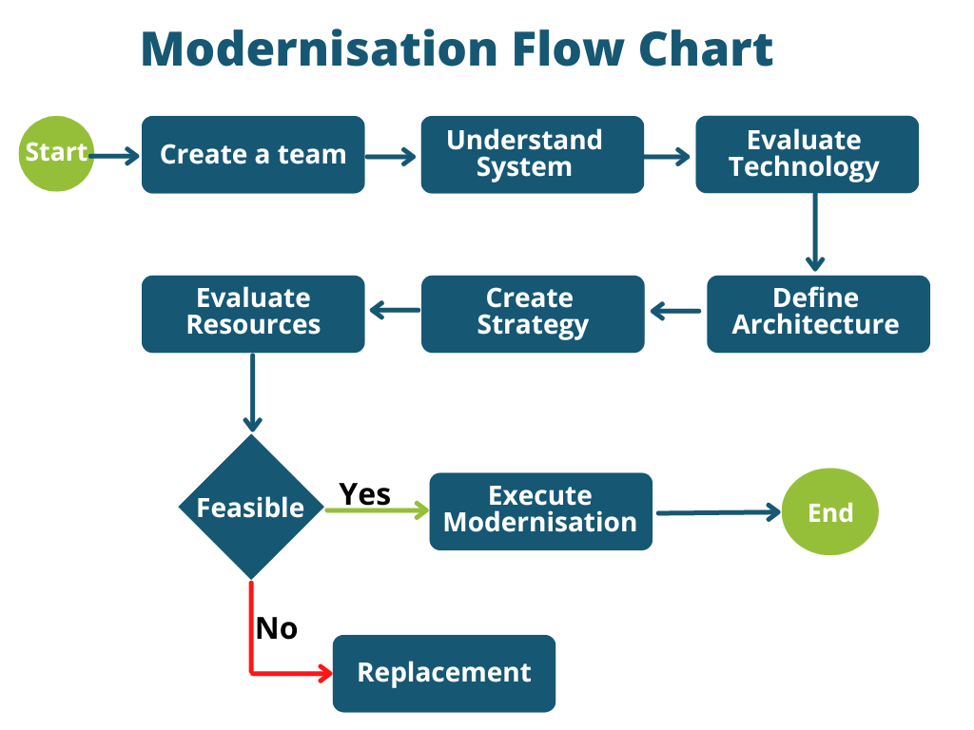

After a meeting with all the stakeholders and Pat, it was decided to put the modernization plan across the company. The first system to be modernized will be the PowerShell code.

With Ren and Jalen on my team, we started brainstorming about what we can do with this code, as Ren had already reviewed the code, he brought us up to speed on what he thought it needs to be done and what the system does. In one of the company meetings that is held every Monday, we discover that one of the members of another team had experience in PowerShell so we brought him to work with us on this project.

At our next meeting, we evaluated the technology and architecture of the system and decided what strategy we would use to fix and modernize this code, and also, an estimate of the resources need for this. After a meeting with our manager Pat where we brought up our plan for the code, it was agreed that this piece of code was worth the time to fix, and we started to execute the modernization of the code.